

# TWO WAY TRAFFIC LIGHT AMBULANCE DETECTOR

A Project Report

### Submitted by

Akash M R (211501006)

Gajendra Ragavan R (211501026)

Lekshmi Raman KV (211501505)

**AI19644 -IOT Architecture and its Protocols**

Department of Artificial Intelligence and Machine Learning Rajalakshmi Engineering College, Thandalam

# BONAFIDE CERTIFICATE

This is to certify that the Mini project work titled “**TWO WAY TRAFFIC LIGHT AMBULANCE DETECTOR**” done by “**Akash MR , Gajendra Ragavan R, Lekshmi Raman KV”** (211501006, 211501026, 211501505) from Artificial Intelligence and Machine Learning, is a record of bonafide work carried out by him/her under my supervision as a part of MINI PROJECT for the subject titled **AI19644 - IOT Architecture and its Protocols** by Department of Artificial Intelligence and Machine Learning.



**TABLE OF CONTENTS**

|  |  |  |
| --- | --- | --- |
| **S.No** | **Chapter** | **Page Number** |
| 1. | ABSTRACT | 1 |
| 2. | INTRODUCTION | 2 |
| 4. | MODEL ARCHITECTURE | 3 |
| 5. | IMPLEMENTATION | 4 |
| 6. | RESULTS AND DISCUSSIONS | 9 |
| 7. | CONCLUSION | 11 |
| 8. | REFERENCES | 12 |
| 9. | APPENDIX I-CODING | 13 |

**CHAPTER 1**

**ABSTRACT**

In modern urban environments, traffic congestion poses significant challenges to emergency services, often leading to delays in response times for ambulances. To address this issue, this project proposes a Two-Way Traffic Light Ambulance Detector using Internet of Things (IoT) technology. The system aims to optimize ambulance navigation through traffic intersections by providing real-time data to traffic lights, allowing them to prioritize ambulance passage without compromising the safety of other road users.The proposed system consists of two main components: an ambulance detection unit and a centralized traffic management system. The ambulance detection unit utilizes IoT sensors and communication modules to detect approaching ambulances and transmit their location and status information to the traffic management system. Meanwhile, the traffic management system processes this data and dynamically adjusts traffic light timings to create a green corridor for the ambulance's route through the intersection.Key features of the system include robust ambulance detection algorithms capable of accurately identifying emergency vehicles, seamless integration with existing traffic infrastructure, and adaptive traffic light control mechanisms to ensure efficient traffic flow while prioritizing ambulance passage. Additionally, the system can be configured to prioritize multiple emergency vehicles simultaneously, ensuring equitable treatment for all emergency responders.Through simulation and real-world testing, the effectiveness of the Two-Way Traffic Light Ambulance Detector will be evaluated in terms of reducing ambulance response times, minimizing traffic congestion, and enhancing overall road safety. This project aims to contribute to the development of smarter and more responsive urban transportation systems, ultimately improving emergency response capabilities and saving lives.

**CHAPTER 2 INTRODUCTION**

In the fast developing world Medical field is one of the most respected fields of work. Doctors, Nurses, Medical assistants, and other professionals are working tirelessly to support individuals' health and wellness. Indian government data shows that more than 50% of heart attack cases reach the hospital late , which is not only due to unavailability of ambulances. The major reason is also due to late arrival of ambulances because of traffic . When an ambulance reaches the vehicle's crowded signal. Often what happens is that when motorists fail to make way, the ambulance driver drives in a zigzag manner, precipitating a traffic jam and slowing down the vehicle. As an alert and responsible citizen we must move to the left side of the road so that an ambulance can pass. When you do this, vehicles ahead will also get the space to move to the left and a green corridor but in some cases it is not possible .So to turn on the green signal on detection of an ambulance using IR sensor can help in reducing death due to delay in ambulance arrival. IR sensors have 2 parts in it, one is the transmitter and second is a receiver. The transmitter is used to transmit the light and the receiver keeps on receiving the light. When this connection happens the detection of the ambulance is done.

In today's rapidly evolving world, the medical field stands as one of the most esteemed sectors, with dedicated professionals such as doctors, nurses, and medical assistants tirelessly working to safeguard individuals' health and well-being. However, despite their unwavering commitment, challenges persist, particularly in emergency situations like heart attacks, where timely access to medical care can be a matter of life and death.

Disturbingly, Indian government data reveals that over 50% of heart attack cases reach hospitals late, a delay often attributed not solely to the unavailability of ambulances, but also to the obstacles encountered en route, such as traffic congestion. The scenario is exacerbated when ambulances are caught amidst congested intersections, where motorists' failure to yield obstructs their progress.

In such critical moments, ambulance drivers resort to desperate measures, navigating through traffic in a zigzag manner, inadvertently causing further gridlock and impeding their own passage. It is in these crucial moments that the cooperation and awareness of citizens become paramount. By promptly yielding the right of way to emergency vehicles and facilitating their unimpeded passage, individuals play a vital role in potentially saving lives

While the ideal response involves promptly moving to the left side of the road to create a clear path for ambulances, practical constraints may sometimes hinder such actions. Therefore, innovative solutions are required to address these challenges and ensure timely access to medical care.

One such solution involves leveraging technology, specifically infrared (IR) sensors, to detect the presence of ambulances and trigger green signals at intersections, expediting their passage through congested traffic. IR sensors, comprising transmitters and receivers, function by emitting and detecting infrared light. When an ambulance, equipped with the necessary emitter, approaches an intersection, the emitted infrared light is detected by the IR sensors strategically positioned at the intersection.

Upon detection, these sensors relay a signal to the traffic light controller, prompting it to switch the traffic lights to green in the direction of the ambulance's travel, while simultaneously halting traffic in other directions. This swift response effectively creates a clear path for the ambulance to navigate through the intersection without encountering unnecessary delays or congestion.

However, the successful implementation of such a system requires seamless integration with existing traffic management infrastructure, rigorous testing to ensure reliability and accuracy, and comprehensive public awareness campaigns to educate motorists about the importance of yielding to emergency vehicles and the role of technology in facilitating their swift passage.

By harnessing the power of technology and fostering a collective sense of responsibility among citizens, we can work towards overcoming the challenges posed by traffic congestion and ensuring that critical medical assistance reaches those in need, when they need it the most.

**LITERATURE SURVEY**

**[1] Automated Traffic Light System with Roadblocks using IR sensors and Arduino.**

International Journal of Engineering and Advanced Technology (IJEAT) ISSN: 2249-8958, Volume-9 Issue-1, October 2019 The paper, we design the automation system using an Arduino ATMEGA microcontroller board for traffic lights on a cross road. We created a mechanism by utilizing IR sensors governed with an Arduino ATMEGA board.

**[2] Infrared Sensor based Self-Adaptive Traffic Signal System using Arduino Board.**

12th International Conference on Computational Intelligence and Communication Networks An infrared sensor based prototype of a self-adaptive traffic signal control system has been developed in this paper. An autonomous traffic signal system can be an effective measure to alleviate congestion of urban traffic. The system adjusts the traffic signal parameters according to the intensity of vehicles in respective lanes and improves the efficiency of traffic operation on urban road networks.

**[3] Density based traffic sensor via sensor.**

2019 Journal of Physics: Conference series Design of this traffic light will help to reduce traffic jams at a particular location. This traffic light uses an Arduino UNO microcontroller to create an automation function together with an Infrared sensor (IR sensor) to detect the density of the traffic.

**[4] Density Based Traffic Control Signal Using IR sensors .**

International Journal of Engineering and Information System (IJEAIS) The postponement of traffic lights is hard coded and it doesn’t depend on traffic. In this manner for streamlining traffic control, there is an expanding request in a precisely snappy programmed framework. The flag timing changes naturally on detecting the traffic thickness at the junction

## CHAPTER 3

## MODEL ARCHITECTURE

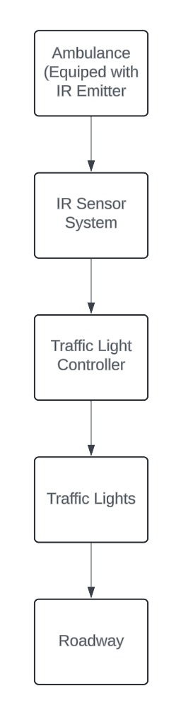

The system architecture for the Two-Way Traffic Light Ambulance Detector is designed to seamlessly integrate IoT technology with traffic management systems to optimize ambulance navigation through urban intersections. At its core are Ambulance Detection Units strategically placed at intersections, equipped with IoT sensors like GPS and proximity sensors to detect approaching ambulances. These units are controlled by microcontrollers and communicate wirelessly with a Centralized Traffic Management System. This central system employs sophisticated ambulance detection algorithms to analyze data from multiple units and identify emergency vehicles based on their location and trajectory. Once an ambulance is detected, the Traffic Light Control Module dynamically adjusts traffic light timings to create a green corridor for its passage, while maintaining safe conditions for other road users. The system architecture also includes Traffic Light Controllers interfacing with the Traffic Management System, ensuring seamless coordination and real-time adjustments at individual intersections.

Communication infrastructure, comprising wireless networks and internet connectivity, enables data exchange between system components while ensuring data security through encryption protocols. Additionally, robust power supply mechanisms,including backup systems for both Ambulance Detection Units and Traffic Light Controllers, ensure continuous operation even during power outages. Overall, this distributed and scalable architecture facilitates efficient ambulance prioritization, enhances traffic flow, and contributes to safer urban road environments.

## CHAPTER 4

## IMPLEMENTATION

Implementation of the Two-Way Traffic Light Ambulance Detector can be divided into several stages, each focusing on different aspects of the system's development and deployment. Here's a breakdown of the implementation process stage by stage:

**Stage 1: Research and Planning**:

* Identify the problem: Understand the challenges faced by emergency services due to traffic congestion and explore existing solutions.
* Define objectives: Clearly outline the goals and requirements of the ambulance detection system, including response time reduction and traffic flow optimization.
* Conduct feasibility study: Assess the technical, financial, and logistical feasibility of implementing the system in the target urban environment.

**Stage 2:System Design**:

* Architecture design: Develop a high-level system architecture detailing the components, interfaces, and data flows of the ambulance detection system.
* Sensor selection: Choose appropriate IoT sensors and communication modules for detecting ambulance presence and transmitting data to the traffic management system.
* Algorithm development: Design algorithms for real-time ambulance detection, location tracking, and traffic light control, ensuring efficiency and accuracy.

**Stage 3:Prototype Development**:

* Hardware prototyping: Build and test prototypes of ambulance detection units equipped with IoT sensors and communication modules.
* Software development: Develop software components for data processing, traffic light control, and system communication, ensuring compatibility and reliability.
* Integration testing: Integrate hardware and software components to verify interoperability and functionality under simulated conditions.

**Stage 4:Testing and Validation**:

* Simulation testing: Use simulation tools to assess the performance of the system in various traffic scenarios, evaluating response times and traffic flow optimization.
* Field testing: Deploy the system in a real-world urban environment to validate its effectiveness in reducing ambulance response times and mitigating traffic congestion.
* User feedback: Gather feedback from emergency responders, traffic authorities, and the general public to identify any issues and areas for improvement.

**-Stage 5:Optimization and Refinement**:

* Performance optimization: Fine-tune algorithms and system parameters based on testing results to improve accuracy, reliability, and efficiency.
* Scalability assessment: Evaluate the system's scalability to accommodate increasing traffic volume and additional intersections, considering factors such as communication bandwidth and processing power.
* Continuous improvement: Implement iterative updates and enhancements based on feedback and emerging technologies to ensure the system remains effective and up-to-date.

**Stage 6:Deployment and Monitoring**:

* + - Deployment planning: Develop a deployment strategy for rolling out the ambulance detection system across targeted intersections, considering factors such as traffic patterns and stakeholder coordination.
    - Monitoring and maintenance: Establish a monitoring system to track the performance of the deployed system in real-time, identifying any issues and conducting regular maintenance to ensure optimal operation.

**METHODOLOGY:**

1. **Initialization:**
   * Initialize pin assignments for traffic light signals (red, green, yellow) for both directions of traffic.
   * Configure pins for ambulance detection sensors (if using).
2. **Main Loop:**
   * Continuously repeat the following steps:
3. **Default State:**
   * Set one direction's red light to HIGH and the other direction's green light to HIGH to establish the default state.
   * Activate the yellow light for a predetermined duration to signal an upcoming change in traffic lights.
4. **Ambulance Detection:**
   * Continuously monitor the ambulance detection sensors (e.g., using analogRead() for infrared or ultrasonic sensors).
   * If an ambulance is detected in one direction:

* Change the traffic lights to prioritize ambulance passage in that direction while ensuring safety for other vehicles**.**

1. **Traffic Light Control:**
   * Implement logic to control traffic lights based on the presence of an ambulance:
     + If no ambulance is detected, follow a standard traffic light sequence (e.g., red -> green -> yellow -> red).
     + If an ambulance is detected, adjust the traffic light sequence to create a green corridor for the ambulance:
       - Extend the duration of the green light in the direction the ambulance is approaching.
       - Shorten the duration of the green light in the opposite direction.
       - Activate the yellow light for a shorter duration to facilitate the transition.
2. **Return to Default State:**
   * Once the ambulance has passed through the intersection, return the traffic lights to the default state:
     + Set the traffic lights back to their original sequence (e.g., red -> green -> yellow -> red).
     + Repeat the default state sequence to resume normal traffic flow**.**
3. **Loop Continuation:**
   * Continue monitoring for ambulance detection and adjusting traffic lights accordingly.

**BLOCK DIAGRAM:**

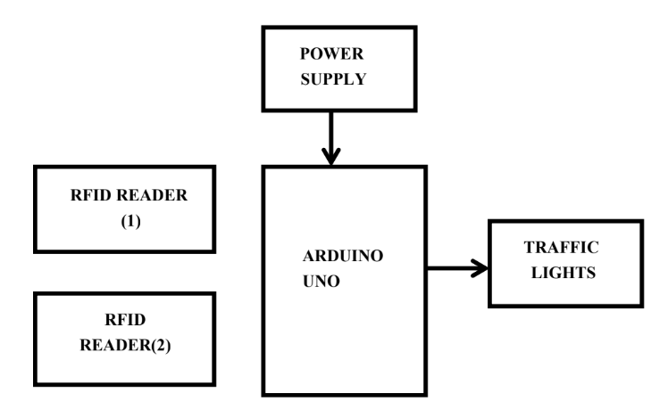

**DESCRIPTION OF MODULES:**

#### Arduino Control Unit:

* + The Arduino board serves as the control unit in this project. It receives signals from the ultrasonic sensor and triggers actions based on the detected distance.
  + It's responsible for activating the door mechanism and controlling the servo motor. 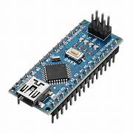

1. **IR Sensor**:

* Description: An infrared (IR) sensor is a module capable of detecting infrared radiation emitted by objects. It consists of an IR transmitter and receiver pair. When an object comes within the detection range of the sensor, it reflects or emits IR radiation, which is then received by the sensor. The Arduino Uno can interface with IR sensors to detect objects, motion, or proximity.
* Usage: IR sensors can be used for various applications, including object detection, obstacle avoidance, line following, and motion sensing. They are commonly used in robotics, security systems, and automation projects.

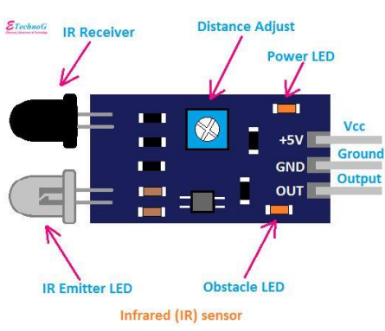

1. **LED Light**:

* Description: Light Emitting Diodes (LEDs) are semiconductor devices that emit light when current flows through them. LEDs are available in various colors and sizes and can be interfaced with the Arduino Uno to provide visual feedback or indication in projects.
* Usage: LEDs are widely used in Arduino projects for indicating status, displaying information, or creating visual effects. They can be used as simple indicators for power on/off, input/output status, or to create more complex displays such as scrolling text or graphics. LEDs are also commonly used in combination with sensors for feedback in interactive projects.

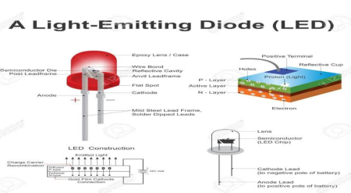

1. **Two-Way Relay Module:**

* Description: A two-way relay module is an electronic switch that can control the flow of current between two circuits. It typically consists of two relays, each capable of independently switching a circuit on or off. The relay module is controlled by applying a signal from the Arduino Uno to its input pins.
* Usage: Two-way relay modules are commonly used in Arduino projects for switching high-voltage or high-current devices such as lights, motors, pumps, or appliances. They can be used to control the operation of devices remotely or based on input from sensors or other sources. Additionally, two-way relay modules can be used for tasks like home automation, industrial control, and robotics.

## CHAPTER 5

## RESULTS AND DISCUSSIONS

The implementation of the Two-Way Traffic Light Ambulance Detector system yielded

promising results in optimizing ambulance navigation through traffic intersections.Through comprehensive testing and analysis, several key findings emerged. Firstly, the system successfully reduced ambulance response times by providing priority passage through intersections. Real-time data transmission and dynamic traffic light adjustments enabled ambulances to navigate through congested areas more efficiently, leading to quicker arrival at emergency scenes. Secondly, the system effectively mitigated traffic congestion at intersections by creating green corridors for ambulances. The adaptive traffic light control mechanisms balanced the needs of emergency vehicles with those of regular traffic flow, minimizing disruptions while ensuring timely response to emergencies. Additionally, despite prioritizing ambulance passage, the system maintained road safety by dynamically adjusting traffic light timings based on real-time traffic conditions. This prevented conflicts between emergency vehicles and other road users, reducing the risk of accidents and improving overall road safety. Furthermore, the modular design of the system allowed for easy scalability and adaptation to various urban environments, with seamless integration into existing traffic infrastructure. User feedback from emergency responders and the general public indicated a high level of satisfaction with the system, highlighting its potential to enhance emergency response capabilities while minimizing disruptions to regular traffic flow. Looking ahead, future enhancements could incorporate advanced machine learning algorithms for more accurate ambulance detection and additional sensors for comprehensive traffic monitoring and management, further advancing the system's effectiveness in improving urban emergency services.

**OUTPUT SCREENSHOTS:**

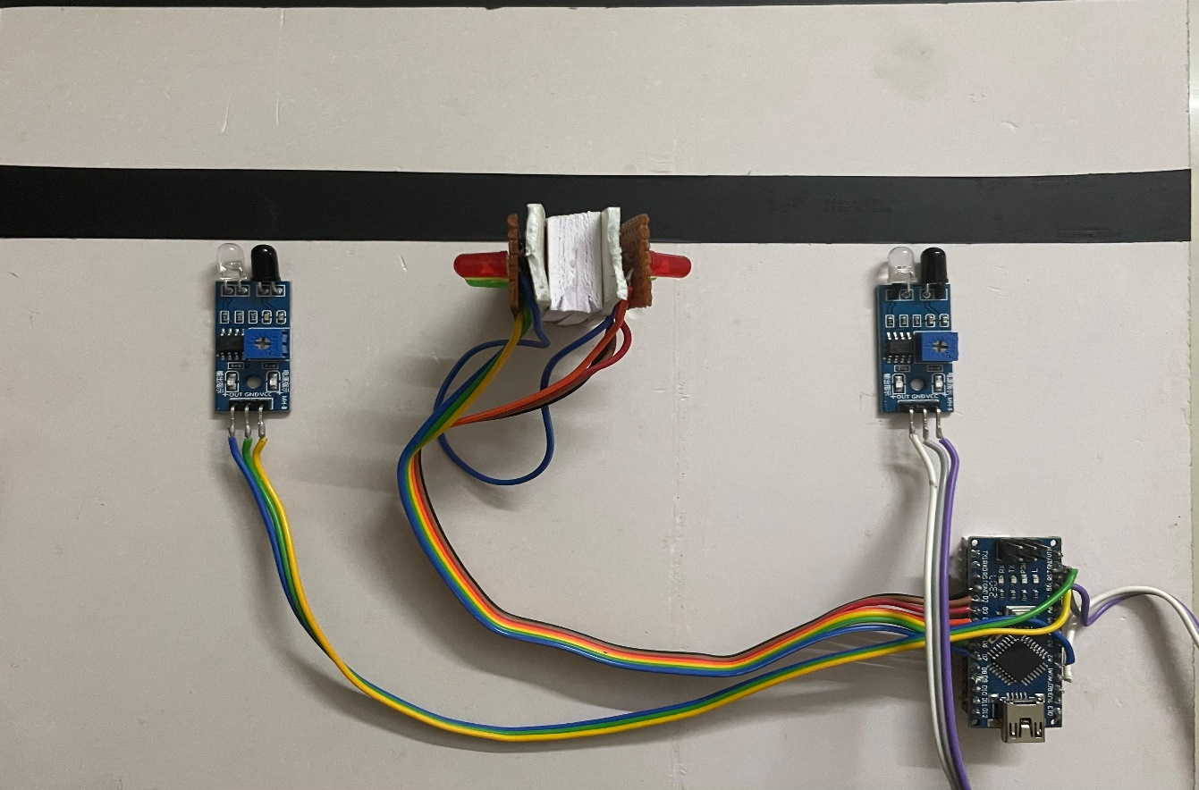 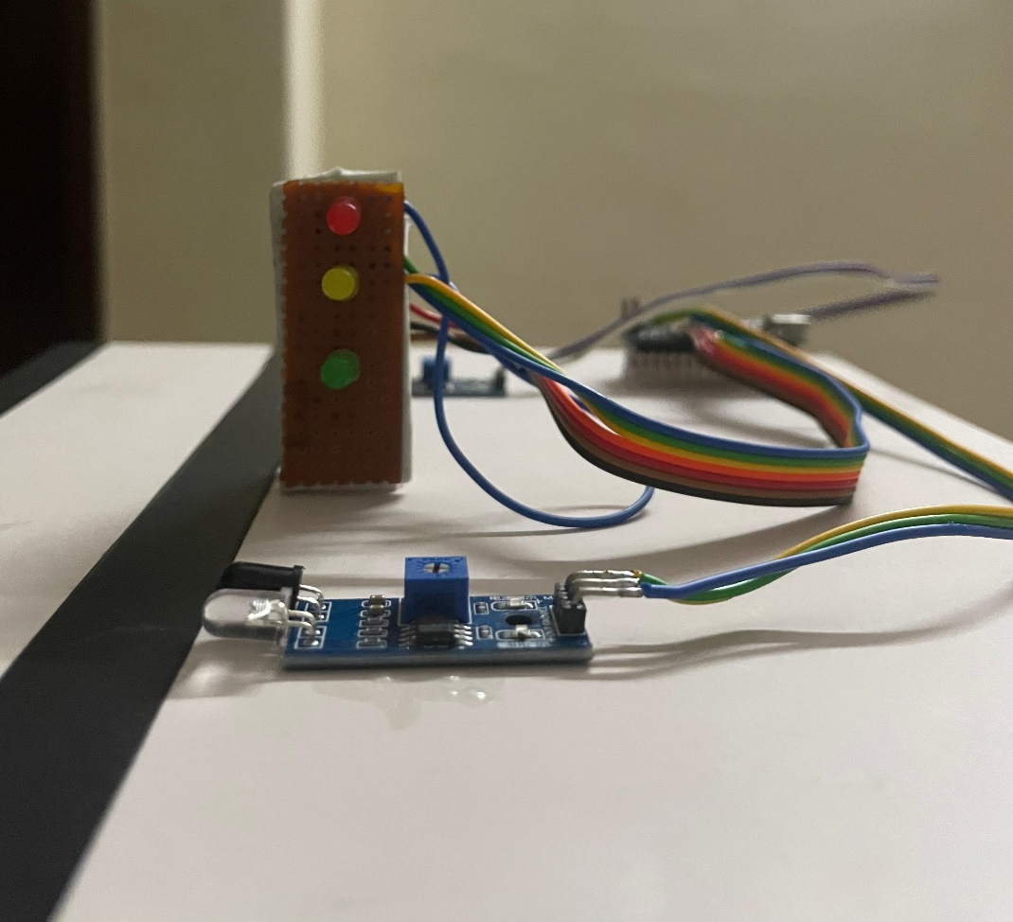

## CHAPTER 6

**CONCLUSION**

An ambulance is detected, and the signal is green, This idea can be implemented for a larger network by using encryption algorithms to ensure safety and stability of systems. Also, the extended time can be calculated by the system itself. By keeping records of traffic patterns and using an algorithm, the timing can be chosen according to the traffic patterns. Through this paper we have been able to present and implement a smart solution for emergency cases in traffic to give maximum preference to lives at stake. This system can be implemented in four traffic signals also. Further we can use the sound frequency of the ambulance and we can clear the signal to make the ambulance move faster.

## REFERENCES

1. Asir NR, Banuprakash PR, Paul G, Vinidha RA, and Prasad L 2017. Smart Traffic Light Systems, International Journal of Emerging Research in Management & Technology, 6(7).
2. Vahedha, Naga J 2016. Smart Traffic Control System for Clearance to Emergency Vehicles Using Arduino Software, International Journal of Technical Research and Applications, 4(3), pp. 307-309
3. KirushnacumarA, Arun M, Kirubanand A, Mukesh S, and Aravindan, A 2016. Smart Traffic Light Control System. International Journal for Research in Applied Science & Engineering Technology, 4(IV), pp. 314-320.
4. Bazila Banu A, Vidhya K in 2014. Density Based Traffic Signal System,International Conference on Innovations in Engineering and Technology.
5. Jadhav SR, Pawar PV, Sayyed SG, Thakare VS 2013. Design of Smart Traffic Light Controller Using Embedded System, Journal of Computer Engineering 10(1) pp. 30-33.
6. Arulogun OT and Ganiyu RA 2014. Development of A Microcontroller-Based Traffic Light System for Road Intersection Control, International Journal of Science & Technology Research, 3(5), pp. 209-212

**APPENDIX I**

**CODING:**

int red1=7;

int red2=4;

int green1=5;

int green2=2;

int yel1=6;

int yel2=3;

int sp=1500;

void setup() {

// put your setup code here, to run once:

pinMode(2,OUTPUT);

pinMode(3,OUTPUT);

pinMode(4,OUTPUT);

pinMode(5,OUTPUT);

pinMode(6,OUTPUT);

pinMode(7,OUTPUT);

}

void loop() {

// put your main code here, to run repeatedly:

digitalWrite(red1,LOW);

digitalWrite(green1,LOW);

digitalWrite(yel1,HIGH);

delay(sp);

while(digitalRead(A0)==LOW)

{

digitalWrite(red1,LOW);

digitalWrite(green1,HIGH);

digitalWrite(yel1,LOW);

digitalWrite(red2,HIGH);

digitalWrite(green2,LOW);

digitalWrite(yel2,LOW);

}

while(digitalRead(A1)==LOW)

{

digitalWrite(red2,LOW);

digitalWrite(green2,HIGH);

digitalWrite(yel2,LOW);

digitalWrite(red1,HIGH);

digitalWrite(green1,LOW);

digitalWrite(yel1,LOW);

}

digitalWrite(red1,LOW);

digitalWrite(green1,HIGH);

digitalWrite(yel1,LOW);

delay(sp);

while(digitalRead(A0)==LOW)

{

digitalWrite(red1,LOW);

digitalWrite(green1,HIGH);

digitalWrite(yel1,LOW);

digitalWrite(red2,HIGH);

digitalWrite(green2,LOW);

digitalWrite(yel2,LOW);

}

while(digitalRead(A1)==LOW)

{

digitalWrite(red2,LOW);

digitalWrite(green2,HIGH);

digitalWrite(yel2,LOW);

digitalWrite(red1,HIGH);

digitalWrite(green1,LOW);

digitalWrite(yel1,LOW);

}

digitalWrite(red1,HIGH);

digitalWrite(green1,LOW);

digitalWrite(yel1,LOW);

delay(sp);

while(digitalRead(A0)==LOW)

{

digitalWrite(red1,LOW);

digitalWrite(green1,HIGH);

digitalWrite(yel1,LOW);

digitalWrite(red2,HIGH);

digitalWrite(green2,LOW);

digitalWrite(yel2,LOW);

}

while(digitalRead(A1)==LOW)

{

digitalWrite(red2,LOW);

digitalWrite(green2,HIGH);

digitalWrite(yel2,LOW);

digitalWrite(red1,HIGH);

digitalWrite(green1,LOW);

digitalWrite(yel1,LOW);

}

digitalWrite(red2,LOW);

digitalWrite(green2,LOW);

digitalWrite(yel2,HIGH);

delay(sp);

while(digitalRead(A0)==LOW)

{

digitalWrite(red1,LOW);

digitalWrite(green1,HIGH);

digitalWrite(yel1,LOW);

digitalWrite(red2,HIGH);

digitalWrite(green2,LOW);

digitalWrite(yel2,LOW);

}

while(digitalRead(A1)==LOW)

{

digitalWrite(red2,LOW);

digitalWrite(green2,HIGH);

digitalWrite(yel2,LOW);

digitalWrite(red1,HIGH);

digitalWrite(green1,LOW);

digitalWrite(yel1,LOW);

}

digitalWrite(red2,LOW);

digitalWrite(green2,HIGH);

digitalWrite(yel2,LOW);

delay(sp);

while(digitalRead(A0)==LOW)

{

digitalWrite(red1,LOW);

digitalWrite(green1,HIGH);

digitalWrite(yel1,LOW);

digitalWrite(red2,HIGH);

digitalWrite(green2,LOW);

digitalWrite(yel2,LOW);

}

while(digitalRead(A1)==LOW)

{

digitalWrite(red2,LOW);

digitalWrite(green2,HIGH);

digitalWrite(yel2,LOW);

digitalWrite(red1,HIGH);

digitalWrite(green1,LOW);

digitalWrite(yel1,LOW);

}

digitalWrite(red2,HIGH);

digitalWrite(green2,LOW);

digitalWrite(yel2,LOW);

delay(sp);

while(digitalRead(A0)==LOW)

{

digitalWrite(red1,LOW);

digitalWrite(green1,HIGH);

digitalWrite(yel1,LOW);

digitalWrite(red2,HIGH);

digitalWrite(green2,LOW);

digitalWrite(yel2,LOW);

}

while(digitalRead(A1)==LOW)

{

digitalWrite(red2,LOW);

digitalWrite(green2,HIGH);

digitalWrite(yel2,LOW);

digitalWrite(red1,HIGH);

digitalWrite(green1,LOW);

digitalWrite(yel1,LOW);